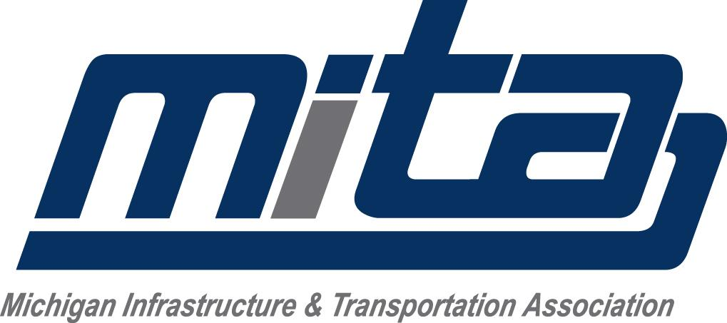

COVID-19 Preparedness and Response Plan for Businesses and Offices

- Restricting the number of workers on-premises to no more than is strictly necessary.
  - Promoting remote work to the fullest extent possible.
  - Unnecessary visitors will be strictly prohibited.
- Keeping people at least six feet from one another to the maximum extent possible.
  - Communication will be done electronically whenever possible.
  - Breaks and lunches will be taken staggered and individually.
  - Employees will be encouraged to spend breaks and lunches outdoors partaking in activities such as walks.
- Increasing standards of cleaning and disinfection.
  - Touch points will be disinfected regularly.
    - If surfaces are dirty, they should be cleaned using a detergent or soap and water prior to disinfection.
    - For disinfection, most common EPA-registered household disinfectants should be effective.
    - Rubber gloves will be provided and worn during the cleaning processes.
    - Employers will work with their local and state health departments to ensure appropriate local protocols and guidelines, such as updated/additional guidance for cleaning and disinfection, are followed, including for identification of new potential cases of COVID-19.
  - Employees will be responsible for cleaning and disinfection of personal space and equipment.
- Adopting policies to prevent workers from entering the premises if they display symptoms of COVID-19.
  - Employees will be instructed to quarantine if they have been in contact with another person who is positive or displays symptoms of COVID-19. Mandatory 14 day self-quarantines will be implemented.
  - Close off areas visited by ill persons. Open outside doors and windows and use ventilating fans to increase air circulation in the area. Wait 24 hours or as long as practical before beginning cleaning and disinfection.
- Utilization of Personal Protective Equipment.
  - CDC recommended that masks be available for all personnel on-premises.
  - Rubber gloves will be available for tasks where they are deemed necessary.
- Follow normal preventive actions while at work and home, including cleaning hands and avoiding touching eyes, nose, or mouth with unwashed hands.
  - Hand wash stations will be provided, cared for and maintained by the employer.
  - Additional times hand washing is recommended:
    - After blowing one’s nose, coughing, or sneezing.
    - After using the restroom.
    - Before eating or preparing food.

